

**NUTECH VENTILATOR**

**SYSTEM REQUIREMENT SPECIFICATION**

Version 3.0

Revision history

|  |  |  |  |  |  |  |
| --- | --- | --- | --- | --- | --- | --- |
| **Title** | **Document Version #** | **Changes in Current Version** | **Date of Release**  **(Current)** | **Approved Signature** | **Previous**  **Version**  **#** | **Date of Release**  **(Previous)** |
| NuVENT System requirement Document -SyRS | v1.0 | Creation of document | 14/07/2020 |  |  |  |
|  | v2.0 | Added Design and Project Diagrams | 01/08/2020 |  | v1.0 | 14/07/2020 |
|  | V3.0 | Modified Design Details | 21/09/2020 |  | V2.0 | 01/08/2020 |

**Table of Contents**

List of Figures 4

Introduction 5

1. System Overview 5

1.1. System Context 5

2. System Scope 6

3. System Design 7

3.1. System functions 8

4. Operating Environment 16

4.1. Environment of Use 16

4.2. Target Operators 16

4.3. Target Patient Population 16

4.4. Target Geographical Markets 16

4.5. System Failure 17

5. Assumptions and dependencies 17

6. Definitions 17

7. Acronyms and abbreviations 20

8. System requirements 21

8.1. Functional Requirements 21

8.2. Usability requirements 30

8.3 Performance requirements 32

8.4. Alarm displays Requirements 34

8.5. System Security requirements 35

8.6. Information management requirements 35

8.7. Policy and regulation requirements 35

9. System interface 36

9.1. Hardware Interface 36

9.2. Software Interface 37

9.3. Communication Interfaces 37

10. System operations 37

10.1. Human Machine Integration requirements 37

10.2. Maintenance Requirements 38

10.3. Reliability Requirements 39

11. System modes and Operations 39

11.1. Ventilation modes 40

12. Physical characteristics 42

13. Environmental conditions 42

List of Figures

Figure 1: NuVENT System Design 5

Figure 2: The pneumatic system 9

Figure 3: Electrical System of NuVENT 10

Figure 4: Power Source Battery of NuVENT 10

Figure 5: NuVENT GUI Screen 32

Figure 6: HDMI type A and Display port 36

Introduction

The devastation brought about by the life threatening acute respiratory syndrome coronavirus 2 (SARS-CoV-2, also known as COVID-19) in the communities up and down across the world has been unprecedented and a profoundly distressing experience. In the severe cases, the virus causes damage to the lungs, causing the body's oxygen levels to drop and making it harder to breathe. To alleviate this, a ventilator is used to push air, with increased levels of oxygen, into the lungs.

Simply put, a ventilator takes over the body's breathing process when disease has caused the lungs to fail. This gives the patient time to fight off the infection and recover. These ventilators are all targeted at patients with chronic respiratory failure. NuVENT is designed for both non-ventilation dependent and ventilation-dependent patients including but not limited to COVID-19 patients. Typically, chronically ventilated patients have a variety of restrictive and obstructive pathologies, encompassing Chronic obstructive pulmonary disease (COPD), neuromuscular diseases (ALS, muscular dystrophy, spinal cord damage), and thoracic cage diseases (scoliosis, extreme obesity, etc.).

1. System Overview
   1. System Context

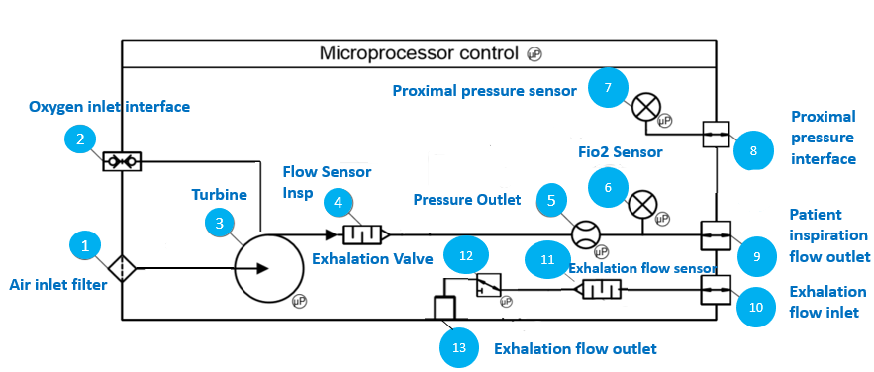**Figure 1:NuVENT System Design**

1. Air inlet filter: double material filter to clean the air before entering the turbine.
2. Oxygen inlet interface: the oxygen standard inlet to connected with oxygen source
3. Turbine: this high speed low-inertia air compressor directly controls the patient flow or pressure through the mainstream pathway.
4. Inspiration flow sensor: monitors the flow coming from the patient inhalation.
5. Pressure outlet: Inspiration pressure outlet for monitoring pressure being delivered to patient.
6. Fio2 Sensor: Oxygen sensor to monitor oxygen percentage being delivered to patient.
7. Proximal pressure sensor: monitors the pressure delivered to the patient when the proximal tubing is connected.
8. Proximal pressure interface: to connect the proximal pressure tubing of the breathing circuit.
9. Patient inspiration flow outlet: to connect the inspiratory tubing of the breathing circuit.
10. Exhalation flow inlet: to connect the exhalation tubing of the breathing circuit.
11. Exhalation flow sensor: monitors the flow coming from the patient exhalation.
12. Exhalation valve: supplied by the turbine, drives the patient circuit exhalation valve.
13. Exhalation flow outlet: to release the exhaled air from the patient.
14. System Scope

Pakistan is currently going through an intense situation with relation to CORONA virus which has hit Punjab and Sindh the worst. Pakistan is yet to embrace the spike in virus which can present itself as a grim situation viz a viz availability of beds and ventilators in state run hospitals. In this situation we need a back-up of ventilators. The recent surge in CORONA virus cases has already choked our health systems while being deficient in critical heath care equipment such as ventilators is also worsening the situation. We need to increase the ventilator capacity such that it should be of high standard and yet affordable. Mechanical ventilator is developed to meet the need of patients who have acute respiratory problems especially as it is need of time due to the country being hit by a rampant COVID 19. The ventilator will push air, with increased levels of oxygen, into the lungs of extremely oxygen deprived patients suffering from variety of restrictive and obstructive pathologies of lungs including Corona virus affected patients. The ventilator will specifically benefit adult patients who are the majority of ones being affected by COVID-19 and could be operated upon remotely. The system will be scalable and other accessories can be added in future if the vendor so wills. The 520b is for non-ventilation dependent patients and 560a is for ventilation dependent patients.

1. **System Design**

The process of ventilation starts with connection of oxygen and air sources to an air flow assembly by a manual device that allows one-way flow and adjustments through the valve. This assembly is fitted with a filter. Hence the concentration of oxygen gas and hence its pressure are monitored by an oxygen sensor and a sensitive pressure sensor.

The mixture of oxygen and the air reaches the turbine which is in principle a mixing chamber too where compression of the gas takes place. The mixed gas will be delivered through a delivery system to the patient circuit via the inspiratory line. The ventilator gas delivery system is composed of an airflow generator capable of supplying a sufficient range of flow and pressure. The flow generator is a low-inertia micro-turbine driven by a brushless electric motor: The valve is a proportional electro-valve. The actuators are controlled according to specific control algorithms by a microprocessor receiving information from the pressure and flow sensors built into the ventilator. Any amount of gas delivered during the inspiratory phase and exhalation during the expiratory phase will pass through the sensitive flow sensor in order to monitor the flow of gas and ruling out any leakage. At the end of airflow generator, a humidifier with built in water trap can be installed and connected to a non-return valve. The pressure sensor will be able to monitor any inspiratory effort done by the patient and deliver the mechanical breath according to the conditions. Additionally, in NuVENT an oxygen sensor connection will be provided connecting at the inspiratory fitting outlet of the ventilator. It will provide some monitoring and alarms to be set on the ventilator for oxygen enrichment survey. An electrical supply management system provides the energy conversions necessary for the operation and switching between the different power sources and the regulated load of the internal battery.

A controlled cooling fan keeps the heat level acceptable for the internal environment of the ventilator. It is servo-controlled to the heat state of the most sensitive components.

The input given to the ventilator to perform the function of ventilation are

1. Breath sequence
2. Oxygen percentage FiO2
3. Tidal volume
4. Inspiration to expiration time ratio I:E
5. Peak pressure PIP
6. Air way pressure Paw
7. PEEP

The outputs are the following based on the input:

1. Pressure waveforms
2. Volume waveforms
3. Flow waveforms
4. Output alarms related to pressure, volume, flow and time
5. Pressure control
6. Volume control
7. PEEP pressure control
   1. System functions

The main function of ventilator is positive pressure ventilation by using an electronically controlled micro-turbine to deliver mixed oxygen and air to the patient. The two main systems that comprise NuVENT are the pneumatic system as shown in Figure 1 and the electronic system as shown in 2 and 3. And the basic functions of the major components is given below.

Pneumatic system which consists of compressed gas as shown in Block diagram 4 consists of a number of sensors for pressure and flow as well as consists of turbine and an oxygen valve.

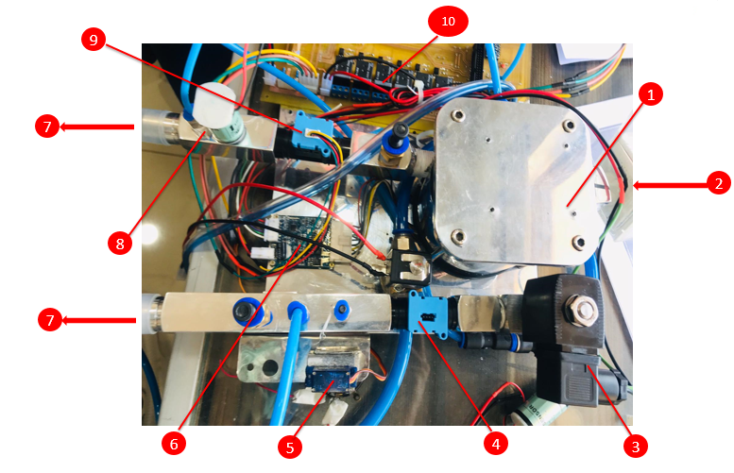

**Figure 2: The pneumatic system**

1. Turbine

2. Bacteria filter (inlet)

3. Exhalation valve

4. Expiratory flow sensor

6. Turbine controller

7. Patient circuit attached

8. FiO2 sensor

9. Inspiratory flow sensor

10. Relays

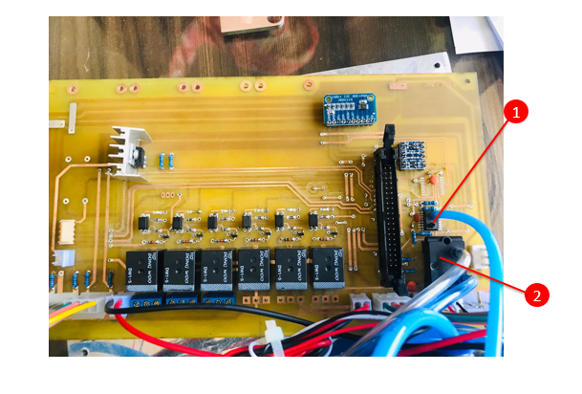

**Figure 3:Electrical System of NuVENT**

1. Inspiratory Pressure sensor

2. Proximal Pressure sensor

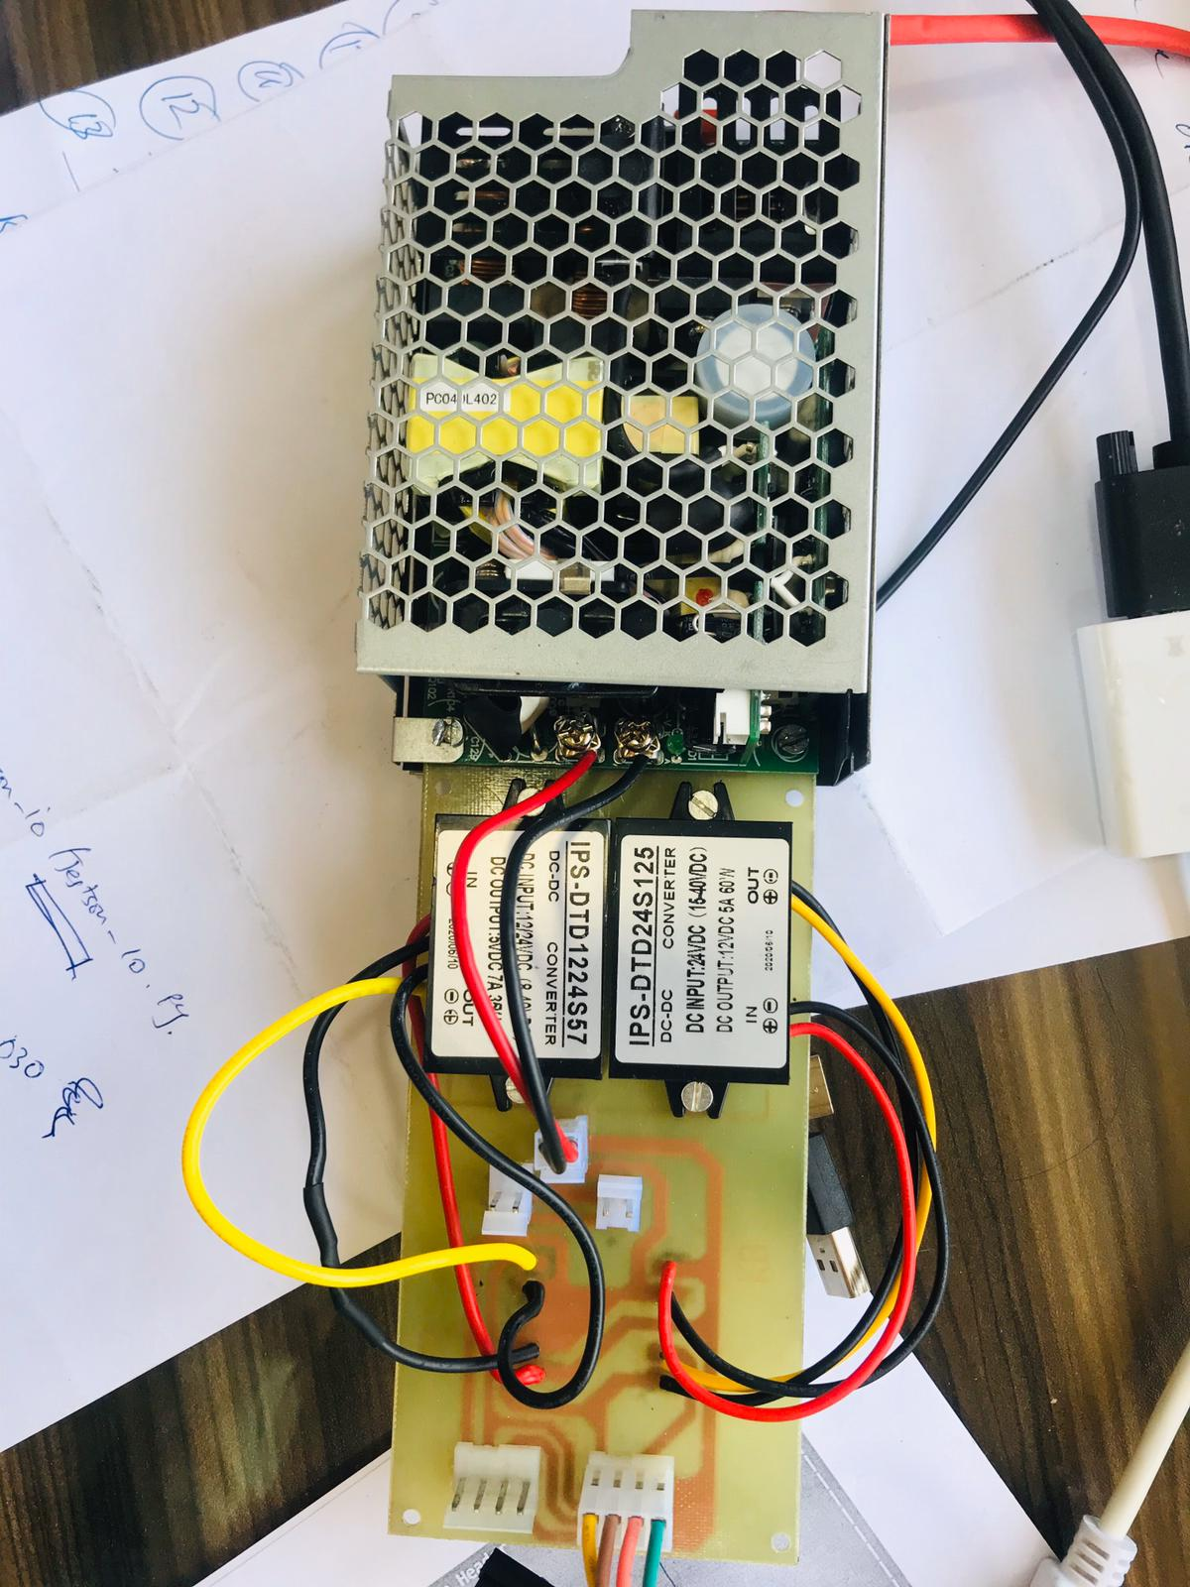

Figure 4: Power Source Battery of NuVENT

The ventilator is powered by electricity to run the compressor to deliver compressed gas mixture to the patients and other components of the ventilator.

The ventilator can be used invasively or non-invasively. The inspiratory volume should be greater than or equal to 200 mL with no leak present.

|  |  |  |  |
| --- | --- | --- | --- |
| **Major component** | **Capabilities** | **Conditions** | **Constraints/ Control** |
| **Pneumatic system** | | | |
| **Turbine Assembly** | The turbine is a low-inertia blower driven by a brushless DC motor that delivers gas by responding to pressure and flow measurements that are processed on the CPU.  A resistive-type temperature sensor resides in the turbine housing. | The turbine spins at a maximum of 50,000 rpm, and can deliver flows of up to 240 lpm  and maximum pressures of 70 cmH2O to 90 cmH2O. | The CPU monitors the temperature by a resistive temperature sensor and will shut the  turbine down if the temperature rises above 70° C while the turbine speed is less than  1000 rpm.  Abnormal turbine speed measurement-  Defect sensor speed |
| **Inspiratory Flow Sensor** | A mass air flow sensor located on the CPU measures inspiratory flow. A portion of the inspired flow is measured by the sensor which contains a heated sensing element and an internal circuitry used to determine the flow rate. | The CPU will use the flow measurement to control the turbine during volume ventilation, determine when an  inspiratory flow trigger occurs (based on the inspiratory sensitivity setting), determine the beginning of exhalation (based on the expiratory sensitivity setting), and to calculate  inspired tidal volume. | Inspiratory flow sensor calibration fault |
| **Proximal Pressure Sensor** | The proximal pressure sensor, located on the CPU measures pressure at the patient wye via a tube that connects from the wye to the Proximal pressure port on the inspiratory block. | This pressure measurement is used in the feedback loop to control the turbine speed during pressure ventilation modes. | Proximal pressure sensor calibration fault.  Negative proximal pressure measurement  for 15 seconds. |
| **Expiratory Pressure Sensor** | The expiratory pressure sensor, located on the CPU PCBA, measures pressure of the gas as it exits the ventilator. | The ventilator substitutes this pressure measurement for the  proximal pressure measurement as a safety backup in the event that the proximal pressure tube becomes disconnected. |  |
| **Exhalation Flow Sensor** | The exhalation flow sensor is a mass air flow sensor that measures exhalation flow upstream of an orifice in the exhalation block. A portion of the exhalation flow is diverted through the sensor which contains a heated sensing element that converts the mass of  air flowing past the element into a voltage. The flow is returned to the exhalation block after it passes through the exhalation flow sensor. The CPU uses the flow measurement to calculate exhaled tidal volume. |  | Exhalation flow sensor calibration fault |
| **Inspiration flow sensor** | Inspiration flow sensor located on CPU, monitors the flow coming from the patient inhalation. The CPU uses the flow measurement to calculate inhaled tidal volume. |  | Inhalation flow sensor calibration fault |
| **Fio2 Sensor** | Fio2 Sensor located on CPU, is a chemical oxygen sensor to monitor oxygen percentage being delivered to patient. |  | Fio2 sensor calibration fault |
| **Patient Circuit** | Ventilator can be used with a single- or double-limb patient  circuit. Both circuits use an exhalation valve to allow ventilation with a set PEEP level. |  |  |
| **Electrical System** | | | |
| **AC to DC Conversion** | AC power enters the Power Management through the main connector with nominal input voltage and frequency ranges of 90 to 250 V AC and 50 to 60 Hz, respectively. | The AC  power is converted to 33 V DC (nominal) and supplies up to 3 A current. |  |
| **DC Voltage Conversion and Distribution** | If AC power is unavailable, the ventilator may be connected through the DC input connector on the Power Management PCBA to an external DC power source (12 to 30 V DC), such as an automobile power port, or will obtain its power directly from the internal  battery (26 V, nominal). | The DC voltage is  is converted to three regulated voltages:  1) 24 V - Used to supply the turbine and fan directly from the Power Management, and distributed to the CPU.  2) 12V - Used by the exhalation valve  3) 5 V — Used by the Power Management electronics and distributed to the CPU for event memory.  4) 3.3 V — Used for RAM voltage supply and distributed to the CPU for monitored  parameter memory. | 1. The Power Management monitors this  voltage to ensure it remains within the range of 22 V to 26 V, the current output is  limited to 4 A.  2. The Power Management monitors this voltage to  ensure it remains within the range of 4.5 to 5.5 V. The current output is limited to 1 A.  3. The Power Management monitors this voltage to ensure it  remains within the range of 3.0 to 3.6 V. The output current is limited to 500 mA. |
| **Internal Battery Charging and Discharging** | The Power Management manages internal battery charging and discharging using a combination of voltage, current, and temperature measurements, and charging time.  Additional protections are in place to prohibit battery charging if charging current and voltage out-of-bounds conditions are detected. | Battery charging occurs in two phases, and only when the ventilator is connected to an AC  power source and when battery voltage drops below 28.5 V. | Battery temperature also affects the ability of the battery to charge and discharge.  Software controls are in place to discontinue battery charging if the battery temperature  is greater than 45° C or less than 0° C. Software also prevents the battery from being used  as the power source if the battery temperature is greater than 60° C or less than -10° C. |
| **CPU** | * It controls breath delivery functions of the ventilator   • displays information to the user through the LCD panel  • communicates with the Power  • provides continuous status and monitoring for errors  • stores ventilator settings, patient data, and events in memory  • interfaces with external devices. |  |  |
| **Breath Delivery Functions** | Software running in the microcontroller on the CPU processes ventilator and alarm  setting inputs from the keyboard. | The microcontroller detects an inspiratory  trigger when a combination of the current and previous inspiratory flow sensor  measurements are greater than the inspiratory sensitivity setting in all modes except for  CPAP, in which case the inspiratory flow readings are compared with an average flow.  Exhalation occurs after the rise time has elapsed and when inspiratory flow has  decreased from peak flow to a predetermined percentage of peak flow (or the set  expiratory sensitivity in PSV). |  |
| **Fan** | A fan, located in the main ventilator compartment and controlled via the Power Management, produces air flow through the ventilator and battery compartments to cool the electronics and to expel any oxygen vented through the exhalation solenoid valve to the outside of the ventilator. Room air enters the ventilator through the vents in  the battery cover at the rear of the device and exits through the cooling vents in the back and sides where the upper and lower housings meet. |  |  |

1. **Operating Environment**

4.1. Environment of Use

NUVENT is meant for ICU ventilation with full support. It is intended to be used in hospitals for critical patients who have respiratory problems who can be conscious or unconscious. This ventilator can be used in medical institutions/home environments only under a trained paramedic supervision or trained carer.

4.2. Target Operators

The ventilator may be operated by:

1. Home care providers

2. Respiratory therapists

3. Physicians & Nurses

4.3. Target Patient Population

The ventilator is intended to provide ventilatory support for adults.

4.4. Target Geographical Markets

The ventilator is intended for use worldwide.

4.5. System Failure

In the event of any failure of the system, the OEM should be contacted and the patient should be shifted to an alternative ventilator. To ensure proper servicing and avoid the possibility of physical injury to personnel or damage to the ventilator, only personnel authorized and qualified by OEM should attempt to service or make authorized modifications to NuVENT ventilator.

1. Assumptions and dependencies

The ventilator is life critical device and therefore must be

1. Reliable and standalone device without the need of any other equipment to operate it
2. It must work continuously for atleast 12 days to provide therapeutic benefit to patients especially on invasive ventilation.
3. This equipment must be provided with suctioning device to suction out copious respiratory secretions that would be more than in normal pneumonia patients, which ultimately affects the compliance of lung and adjustable parameters.
4. Definitions

**Assisted Breath**

A breath for which all or part of the inspiratory or expiratory flow is generated by the ventilator doing work on the patient. Inspiration is assisted if airway pressure rises above the end expiratory value during the inspiratory phase. Expiration is assisted if airway pressure falls below the end expiratory value during the expiratory phase. A mandatory breath is by definition assisted. A spontaneous breath may be assisted or unassisted.

**Breath rate:** The total number of breaths, both machine and spontaneous, delivered by a ventilator in one minute.

**BPM:** An abbreviation for “breaths per minute,” which is the unit of measure for breath rate.

**Breath Rate:** The total number of breaths, both machine and spontaneous, delivered by a ventilator in one minute.

**Cycle:** To end the inspiratory time (and begin expiratory flow)

**Continuous airway pressure:** A positive pressure maintained throughout the breathing cycle; usually associated with unassisted spontaneous breathing but actually occurring during most forms of mechanical ventilation.

**cmH2O:** An abbreviation for “centimeters of water,” which is a unit of measure for pressure.

**Double-Limb Patient Circuit:** Patient circuit with a tube between the ventilator gas outlet and the patient for inspiratory gas and another tube between the patient and the exhalation block for exhalation gas.

**Exhalation Block:** Part of the ventilator that allows the connection of the exhalation limb of the patient circuit. The exhalation block is for single-patient use only.

**Exhalation Phase:** Phase of the breath cycle during which the patient exhales.

**Exhalation/ Exhaled Tidal Volume (VTE)**

Volume exhaled by the patient at each exhalation phase. Exhaled volume measured for all breath types through the exhalation block. Monitored value available only with double-limb patient circuit. Exhaled volume is computed using a five-breath average.

**Expiratory time:** The time period taken from the start of expiratory flow to the start of inspiratory flow.

**Expiratory flow time:** The period from the start of expiratory flow to the moment when expiratory flow ends.

**FiO2 Sensor:** The sensor that measures the amount of oxygen being delivered to the patient.

**Inspiratory time**

The inspiratory time is the time taken for inhalation. For ventilators, the inspiratory time is the amount of time it takes to deliver the tidal volume of air to the lung.

**Inspiratory flow time**

The period from the start of inspiratory flow to the moment when inspiratory flow ends.

**I:E ratio**

Inspiratory: Expiratory ratio refers to the ratio of inspiratory time: expiratory time. In normal spontaneous breathing, the expiratory time is about twice as long as the inspiratory time.

**Inspiratory Phase:** Phase of the breath cycle during which the patient inspires.

**Inspiratory Pressure (Pi)**

The pressure changes above end expiratory pressure required to deliver a tidal volume. The operator-set inspiratory pressure during a pressure control (PC) mandatory breath.

**IMV:** Intermittent mandatory ventilation; a ventilatory pattern in which spontaneous breaths are permitted between mandatory breaths. When the mandatory breath is patient triggered, it is commonly referred to as synchronized IMV (or SIMV).

**Leak:** When ventilating with a double-limb circuit in leak configuration, it is the average unexpected leak during each cycle and over the past 24-hour period. When ventilating with a single-limb circuit there is no average leak.

**Lpm:** Liters per minute (a unit of volume flow rate).

**PEEP:** Positive end expiratory pressure. A positive pressure related to atmospheric pressure maintained during expiration; usually associated with assisted ventilation

**Pressure support:** Pressure support is a mode in which all breaths are patient triggered, pressure limited and patient cycled.

**Patient Wye:** The connector that joins the inspiratory and expiratory limbs of a two-limb patient circuit to the patient airway.

**Set point:** A value of a ventilator output (e.g., inspiratory pressure, tidal volume, inspiratory flow, inspiratory/expiratory times, etc.) that is input as a goal for a breath by the operator

**Stakeholder:** Stakeholder is one that acquires or procures a product or service from a supplier. Other terms commonly are acquirer, buyer, customer, owner, purchaser or internal/organizational sponsor

**Sigh:** A sigh is an increased volume of gas delivered to the patient at a set rate (for example, every 50 breaths).

**Standby:** The operational mode of the ventilator where it is powered (I/O (power) switch set to the I position), but is not ventilating the patient.

**Servo control:** A type of targeting scheme for which the ventilator delivers pressure in proportion to the patient generated volume and/or flow according to a preset model (e.g., the equation of motion). Model parameters are preset by the operator.

**Tidal Volume:** The column of gas, either inhaled or exhaled, during a breath.

**Trigger:** To start inspiration.

**Trigger variable:** The variable (e.g., pressure, volume, flow, time, diaphragmatic EMG, chest impedance) that is used to start the inspiratory phase.

**Vendor:** An organization or individual that enters into an agreement with the customer for the supply of a product or service Other terms commonly used for supplier are contractor, producer, seller or supplier.

**Ventilator:** A medical appliance used for providing artificial respiration to critically ailed patients by moving the gas into and out of the lungs to satisfy the body’s respiratory needs.

**Volume Control:** Maintenance of consistent inspiratory volume waveform despite changing respiratory system mechanics, using feedback control with volume signal.

1. Acronyms and abbreviations

|  |  |
| --- | --- |
| **NuVENT** | National University of Technology Ventilator |
| **PEEP** | Positive End Expiratory Pressure. |
| **PC** | Pressure Control. |
| **VC** | Volume Control |
| **CMV** | Continuous Mandatory Ventilation |
| **A/C** | Assist Control mode |
| **O2** | Symbol for Oxygen gas |
| **PSV** | Pressure support ventilation |
| **A/C** | Assist Control mode |
| **AC/DC** | Alternating Current / Direct Current Conversion |
| **BiPAP** | Biphasic Positive Airway Pressure |
| **PRVC** | Pressure Regulated Volume Control Mode |
| **CPAP** | Continuous positive airway pressure |
| **VTI** | Volume delivered to the patient at each inspiratory phase. |
| **VTE** | Volume exhaled by the patient at each exhalation phase |
| **Rtot** | Total number of breaths per minute |
| **PSV** | Pressure support ventilation |
| **PTS** | Performance Test System |
| **Pi** | Inspiratory Pressure (Pi) |
| **I Sens** | Level of inspiratory effort the patient has to provide during the initiation of a machine breath. |
| **I Time** | Inspiratory time measure. |
| **hPa** | An abbreviation for “hectopascal” |
| **Bpm** | breaths per minute |
| **Lpm** | Liters per minute (a unit of volume flow rate). |
| **PSI** | Pounds per square inch. |
| **PSV** | Pressure support ventilation. |
| **SIMV** | Synchronized Intermittent Mandatory Ventilation |
| **Lpm** | Liters per minute (a unit of volume flow rate). |

1. System requirements

8.1. Functional Requirements

|  |  |  |
| --- | --- | --- |
| **Requirement ID** | **System Requirements** | **Type** |
| NV_SyRs-GEN001 | NuVENT shall deal with adult patients which have severely compromised breathing in ICU settings. | General |
| NV_SyRs-GEN002 | NuVENT shall be plugged into a wall socket to get it starting by switching on the on/off switch at the back of the ventilator. | General |
| NV_SyRs_GEN003 | NuVENT will provide gas and oxygen to deliver a range of oxygen concentration for ventilating patients according to their need. | General |
| NV_SyRs_GEN004 | NuVENT shall provide humidified warm air to keep the lungs from drying by a humidifier installed at the patients’ circuit. | General |
| NV_SyRs_GEN005 | The ventilator shall deliver carefully measured amount of gas to exposed patients by installing an inspiratory flow regulator | General |
| NV_SyRs_GEN006 | Specific percentage of O2 shall be delivered during the inspiration phase in all modes of ventilation according to the patients’ needs ranging from 21-100% with the increment/decrement of 10%. | General |
| NV_SyRs_GEN007 | The ventilator shall read correct parameters for FiO2, Vt, RR, PEEP, PIP and MVe at the interface by providing it with sensors such as gas sensor, flow, volume and pressure sensors. | General |
| NV_SyRs_GEN008 | NuVENT GUI has no physical buttons on it to avoid transmission of germs. | General |
| NV_SyRs_GEN009 | Temperature of humidifier can be adjusted through physical knob on it. | General |
| NV_SyRs_GEN010 | The ventilator shall be able to filter the expelled gas from patient circuit to avoid aerosolized pathogens in the patients’ airways and protect the ventilator from hot and humid air from within the patients. | General |
| NV_SyRs_GEN011 | The ventilator will deliver appropriate inspired volume by setting the tidal volume to ensure added accessories, such as humidifier. | General |
| NV_SyRs_GEN012 | Air inlet filter will deliver filter air from foam and fine particulate to patients to avoid any safety hazards to breathing | General |
| NV_SyRs_GEN013 | The ventilator will maintain PEEP configuration during exhalation phase ranging 0-20 cm H20 in all types of ventilation modes to ensure a positive air way pressure is maintained. | General |
| NV_SyRs_GEN014 | The ventilator will detect target inspiratory volume by adjusting flow profile ranging from 0-120 L/m depending on patient respiratory breaths in volume controlled ventilation mode. | General |
| NV_SyRs_GEN015 | The ventilator will adjust parameters to deliver peak inspiratory pressure PIP in controlled pressure ventilation cycle ranging from 0-40 cm H2O. | General |
| NV_SyRs_GEN016 | The ventilator shall display lifesaving parameters and alarms if any triggered, on the interface for users HIGH PIP, HIGH/ LOW RR, HIGH/ LOW MVe, LOW FiO2 | General |
| NV_SyRs_GEN017 | 1.5 hours power backup when AC power supply is disconnected. | General |
| NV_SyRs_GEN018 | The ventilator will be automatically switched to internal battery when AC power source is disconnected or get lost | General |
| NV_SyRs_GEN019 | The ventilator shall provide an Alarm History Menu where the 10 last occurred alarms are displayed with their occurring time and date. | General |
| NV_SyRs_GEN020 | NuVENT provides self-test which can be performed through GUI and shall allow the maintenance and the check-up of ventilator system service functions | General |
| NV_SyRs_GEN021 | Humidifier power on and off option is available on GUI | General |
| NV_SyRs_GEN022 | Water level in humidifier should be visible. | General |
| NV_SyRs_GEN023 | Proximal sensor is placed in front of patient circuit. | General |
| NV_SyRs_GEN024 | Oxygen cylinder inlet pressure must be greater than 2.5 bar | General |
| NV_SyRs_GEN025 | FiO2 sensor is used to check the oxygen percentage in inspiratory airway. | General |
| NV_SyRs_SW001 | NuVENT GUI shall be switched on and a loading message will be displayed on the interface. | Software |
| NV_SyRs_SW002 | The software will take a 90 to 100 seconds to boot up and display a visual with parameters and waveforms. | Software |
| NV_SyRs_SW003 | NuVENT will store the patient history in nonvolatile memory before turning off in the event of a Power down. | Software |
| NV_SyRs_SW004 | Freeze Waveform control shall enable user to stop the moving waveforms on the waveform panel in order to observe the small details which are usually skipped when graphs are continuously updated. | Software |
| NV_SyRs_MOD001 | NuVENT shall start directly in active ventilation state with the VC-AC mode when the next power switches on again. | Modes |
| NV_SyRs_MOD002 | NuVENT shall allow changes to be made to the settings of the current ventilation mode while ventilation support is inactive (Standby). | Modes |
| NV_SyRs_MOD003 | NuVENT shall allow changing the current ventilation mode to any other applicable ventilation mode while ventilation support is active. | Modes |
| NV_SyRs_MOD004 | Any ventilation mode changes shall apply at the beginning of the next breath cycle during active ventilation. | Modes |
| NV_SyRs_MOD005 | In the pressure-controlled mode NuVENT provides control breath delivery with pressure controlled mandatory ventilation. This ventilation mode is compatible with double limb patient circuit. | Modes |
| NV_SyRs_MOD006 | In volume-controlled mode NuVENT provides control breath delivery with volume controlled mandatory ventilation. This ventilation mode is compatible with double limb patient circuits. | Modes |
| NV_SyRs_MOD007 | NuVENT shall provide assist/control or control breath delivery with volume controlled mandatory ventilation. This ventilation mode shall be compatible with double limb patient circuits. | Modes |
| NV_SyRs_MOD008 | The ventilator shall provide assist/control or control breath delivery with pressure controlled mandatory ventilation. This ventilation mode shall be compatible with double limb patient circuit. | Modes |
| NV_SyRs_MOD009 | NuVENT shall provide synchronized intermittent mandatory ventilation breath delivery with volume controlled mandatory ventilation. This ventilation mode shall be compatible with double limb patient circuits. | Modes |
| NV_SyRs_MOD010 | NuVENT ventilator shall provide synchronized intermittent mandatory ventilation breath delivery with pressure controlled mandatory ventilation. This ventilation mode shall be compatible with double limb patient circuits. | Modes |
| NV_SyRs_MOD011 | The NuVENT shall provide spontaneous or timed breath delivery with Pressure Support spontaneous Ventilation. This ventilation mode shall be compatible with limb patient circuits. | Modes |
| NV_SyRs_MOD012 | The ventilator shall provide Continuous Positive Airway Pressure (CPAP). This ventilation mode shall be compatible with double and single limb patient. | Modes |
| NV_SyRs_MOD013 | Low and High MVe will enable the operator to set a minimum and maximum inspiration minutes volume threshold respectively. | Modes |
| NV_SyRs_MOD014 | The ventilation modes that utilize Low and High MVE setting shall be all modes of ventilation. | Modes |
| NV_SyRs_MOD015 | Low and High RR will enable the operator to set a minimum and maximum inspiration tidal volume threshold respectively.  The ventilation modes that utilize Low and High RR setting shall be all modes of ventilation. | Modes |
| NV_SyRs_MOD016 | Low and High PAW will enable the operator to set a minimum and maximum inspiration tidal volume threshold respectively.  The ventilation modes that utilize Low and High PAW setting shall be all modes of ventilation. | Modes |
| NV_SyRs_MOD017 | The ventilation modes that utilize High RR setting shall be all modes of ventilation. | Modes |
| NV_SyRs_DET001 | NuVENT shall detect the leakages by indicating it with an ALARM. | System detection |
| NV_SyRs_VAR001 | NuVENT shall provide the prescribed pressure for inhalation (IPAP), and a lower pressure for exhalation (EPAP). | Settings |
| NV_SyRs_VAR002 | The patient shall be able to inspire by dropping the airway pressure by inspiration just below the PEEP maintaining a positive pressure at the patient’s lungs during assisted ventilation. | Settings |
| NV_SyRs_VAR003 | NuVENT shall provide a choice between 9 ventilation modes through GUI, which are VC-AC, VCV, VC-SIMV, PC-AC, PCV, PC-SIMV, PSV, CPAP, and BIPAP. | Settings |
| NV_SyRs_VAR004 | The P SUPPORT/ PSV setting shall be within a range of 0 to 40 only in CPAP mode. | Settings |
| NV_SyRs_VAR005 | The operator shall be able to set the tidal volume VT level of controlled volume cycles VCV, VC-AC, VC-SIMV. Vt ranges from 200-1000 ml | Settings |
| NV_SyRs_VAR006 | Positive End Expiratory Pressure PEEP will enable the operator to set the positive pressure level during exhalation phase. Used in all modes of ventilator including CPAP. PEEP ranges from 0-20 cmH2O | Settings |
| NV_SyRs_VAR007 | In CPAP mode PEEP shall be a minimum 5. | Settings |
| NV_SyRs_VAR008 | FiO2 shall enable the operator to set specific percentage of O2 during inspiration phase which is used in all modes. FiO2 adjustment ranges from 21% – 100% with the increment and decrement of 10%. | Settings |
| NV_SyRs_VAR009 | Flow pattern shall enable the operator to set different flow profiles for ventilator to deliver the target inspiratory volume which is used in VC-AC, VCV, VC-SIMV. Flow ranges from 0-120 Lpm | Settings |
| NV_SyRs_VAR010 | RR shall enable operator to set breathing rate level of controlled pressure or volume cycles.  Used in PCV, VCV, PC-AC, VC-AC, PC-SIMV, VC-SIMV modes. RR ranges from 8-35 bpm | Settings |
| NV_SyRs_VAR011 | The inspiration time Ti will enable the operator to set the duration of inspiratory phase.  The ventilation modes that utilize Ti CONTROL setting shall be VC-AC PC-AC,VCV, PCV, VC-SIMV, PC-SIMV and BIPAP Mode. | Settings |
| NV_SyRs_VAR012 | The Ti CONTROL adjustment range shall be 0.4 s to 2.5 s with an I:E not exceeding 1:3 for all ventilation modes. | Settings |
| NV_SyRs_VAR013 | INSP SENS (I SENS)will enable the operator to adjust the sensitivity of the inspiratory trigger which will initiate an inspiration. The ventilation modes that utilize INSP SENS setting shall be PCV, VCV, PSV ST, PC-SIMV, VC-SIMV Mode. | Settings |
| NV_SyRs_VAR014 | The INSP SENS adjustment range shall allow 6 levels of trigger sensitivity | Settings |
| NV_SyRs_VAR015 | The INSP SENS shall be set by default to 2 in CPAP mode, and shall not be adjustable. | Settings |
| NV_SyRs_VAR016 | EXH SENS (E SENS)will enable the operator to adjust the sensitivity of the expiratory trigger which will initiate an expiratory phase.  The ventilation modes that utilize EXH SENS setting shall be PSV, PC-SIMV, VC-SIMV Modes. | Settings |
| NV_SyRs_VAR017 | The EXH SENS setting shall be based on the percentage of inspiratory peak flow if positive convention has been chosen by the user or on the percentage of decrease of the inspiratory peak flow if negative convention has been chosen by the user. | Settings |
| NV_SyRs_VAR018 | MIN INSP TIME (MIN I TIME)will enable the operator to select a minimum inspiration time for the patient. This ensures the operator that the inspiration phase will last at least MIN INSP TIME i-e 1s. MIN INSP TIME setting shall be available to all modes of ventilation. | Settings |
| NV_SyRs_VAR019 | Low PIP will enable the operator to set a PIP minimum threshold. An alarm will occur if the PIP level is below the LOW PIP level during 15 s utilized in VC-AC, VC-SIMV Mode applying to all breath types. | Settings |
| NV_SyRs_VAR020 | The Low PIP (VC-AC) adjustment range shall be 0 to 40 cm H2O | Settings |
| NV_SyRs_VAR021 | The Low PIP (VC-SIMV) adjustment range shall be 2 to 52 cm H2O | Settings |
| NV_SyRs_VAR022 | Inspiratory time versus exhalation time ratio I:E  Range: 1:1 to 1:3  In normal spontaneous breathing, the expiratory time is about twice as long as the inspiratory time. | Settings |
| NV_SyRs_VAR023 | The PIP will enable to set peak inspiratory pressure in controlled pressure cycles. Used in PCV, PC-AC, PC-SIMV  Ranges from 0-40 cm H2O | Settings |
| NV_SyRs_VAR024 | Delta Psupp will enable to set inspiratory pressure level in assisted pressure cycles. Used in only CPAP ranging from 0-40 cmH2O | Settings |
| NV_SyRs_AM001 | A alarm will occur if the PIP level is above the HIGH PIP level. | Alarm |
| NV_SyRs_AM002 | Low MVe will enable the operator to set a minimum inspiration minute volume threshold. An alarm will occur if the exhalation tidal volume level is below the LOW MVe level. |  |
| NV_SyRs_AM003 | High RR will enable the operator to set a maximum total breath rate threshold. An alarm will occur if the R level is above the High R level. |  |
| NV_SyRs_AM004 | NuVENT shall display all alarm messages with a written message flashing while the alarm is active | Alarm signal control |
| NV_SyRs_AM005 | For an alarm that could have a technical root cause in the start an additional message will say “PLEASE RESTART YOUR SYSTEM”. |  |
| NV_SyRs_AM06 | A press on the AUDIO PAUSE / ALARM PAUSE key shall initiate an auditory alarm signal pause of all active alarms during 10 seconds (Assuming that all the active alarms can be inhibited). |  |
| NV_SyRs_AM07 | The ventilator shall annunciate the associated auditory alarm signal, if an alarm condition exists at the end of the audio pause period, while in the event of clearing the alarm condition during this time, NuVENT shall not annunciate anything. |  |
| NV_SyRs_AM008 | The ventilator shall ignore physiologic alarm conditions during ventilation stand-by mode. | Alarm handling |
| NV_SyRs_AM009 | The ventilator shall initiate upto 3 alarms on screen at a time. | Breath alarm |
| NV_SyRs_AM010 | The ventilator shall provide a alarm for high inspiratory pressure when the pressure level goes above the high inspiratory pressure threshold | Pressure Alarms |
| NV_SyRs_AM011 | The ventilator shall reset the high inspiratory pressure alarm condition on the first breath within the alarm threshold and you can reset alarm. |  |
| NV_SyRs_AM012 | Alarm must be triggered, when patient circuit is leaked and results in patient disconnection from ventilator, causing the set value PIP to reaches threshold of Maximum PIP. Audio and visual indication should be displayed on GUI |  |
| NV_SyRs_AM013 | The ventilator shall initiate a alarm if no significant volume can be delivered to the patient. |  |
| NV_SyRs_AM014 | The ventilator shall initiate a alarm in case of a leakage obstruction. |  |
| NV_SyRs_AM015 | NuVENT shall initiate a high priority alarm when the monitored O2 level is lower than 18%. | FIO2 |
| NV_SyRs_AM016 | High RR alarm will be triggered when the total Respiratory rate exceeds the maximum limit set. | RR |

8.2. Usability requirements

Ventilator designed is used for providing oxygen gas under positive pressure to help in breathing. The usability requirements for the software and hardware are:

1. The ventilator must be used only under the responsibility and on the prescription of a doctor.
2. NuVENT must be used for intended purpose to provide mechanical ventilation to adult patients which have severely compromised respiratory system.
3. NuVENT must be operated by a trained personal.
4. The ventilator must not be connected to a patient when ventilation is stopped, because of the danger of inhaling the exhalation gas, primarily carbon dioxide which may lead to suffocation.
5. The ventilator must display the RR and inspiratory time for patient data monitoring requirements
6. The proper function of O2 senor to deliver %age fraction of oxygen must be on display on the GUI.
7. NuVENT must provide a display of pressure being delivered to the patient so that accurate amount of pressure is delivered.
8. NuVENT must be able to provide a means to display monitored inspiratory volume VT, and minute volume MVe.
9. NuVENT must provide a user interface that allows the user to decide to start and stop inspiration and expiration.
10. NuVENT must provide a user interface that allows the user to set the mechanical breaths
11. NuVENT must provide a means to change the inspiratory gas supplied to the patient depending on the patient needs and physiological conditions.
12. NuVENT must provide control over either volume or pressure by adjusting the relevant parameters such as tidal volume and PIP respectively.
13. The operator must be able to handle the alarms due to low or high set values for PCV or VCV such as PIP, Inspiration time, VT and volume flow respectively.
14. The operator must be able to undo any command by pressing it without causing danger to the patient
15. NuVENT must be reliable and be able to run for long periods of time without any interruptions.
16. NuVENT must have a modular system allowing for any future updates and upgradation.
17. Must have the essential features so that lives are not endangered.
18. NuVENT must not be used in event of leaky accessories or faulty mechanics.
19. NuVENT must provide audible and visible display of alarms related to pressure, flow, volume, breath rate.
20. NuVENT must be portable and easily transported from one place to another.
21. NuVENT must be cleaned and regularly checked for any potential infection and maintenance.
22. The surface of NuVENT may become very hot especially under high ambient temperature conditions and therefore care must be taken before and after use.
23. NuVENT must not be near MRI, direct sunlight and high frequency surgical equipment’s.
24. The software must run on any browser and must be user friendly.
25. NuVENT must have an easy to use interface where symbols and signs should be displayed for easy visualization.
26. The user manual should be easy to understand and written in a clear precisely worded English language for all users to comprehend.

To ensure smooth functioning of the ventilator the following key points for usability need to be kept in mind while using the ventilator through the computer touchscreen interface.

1. The ventilator provides audible feedback to the operator to acknowledge any Key press. General statement : increment/decrement/ start/ standby.
2. The ventilator does not allow the operator if he/she attempt to set a parameter to a value that is not allowed by the ventilator.
3. The ventilator provides a visual distinction between parameters that can be modified by the operator and those that cannot be modified by the operator.
4. The ventilator's operator interface is designed such that, if an operator edits a setting, they must tap a knob to confirm before navigating to a different area of the operator interface.
5. If the operator does not tap on knob, a time out occurs which will be equivalent to the operator cancellation.
6. The Figure shows how the system display GUI looks like.

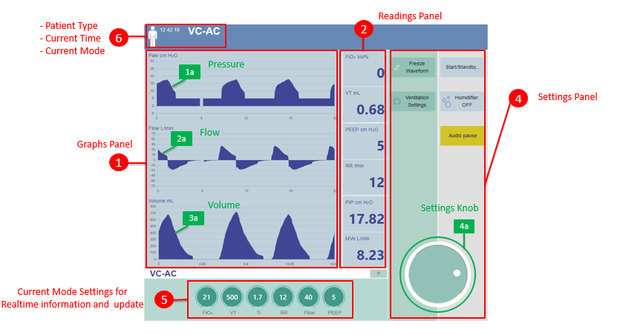

Figure 5:NuVENT GUI Screen

8.3 Performance requirements

1. General ventilation control quality and accuracy

The tolerance of the settings is +/- 10% of the actual value when not specified in the requirement.

1. Inspiratory control pressure overshoot limitation during inspiration pressure rise phase

Peak Inspiratory Pressure (Pinsp/Pip) is from 0-40 cm H2O. If the value exceeds the limit high pressure alarm will be triggered.

1. Inspiratory control pressure accuracy during inspiration steady phase

End Inspiratory Pressure shall be within setting of PIP and delta P with tolerance of +/- (1 cm H2O + 10 %).

1. Peep control overshoot limitation during the exhalation pressure fall phase

During exhalation lungs still contain some positive pressure called PEEP. PEEP ranges from 0-20 cmH2O. The PEEP is set on values 5,10,15,20 cmH2O where actual PEEP should be within PEEP setting +/- (2cm H2O + 10 %).

1. Breath rate accuracy

Actual breath rate shall be within CONTROL R +/- 1 bpm.

1. Inspiratory trigger requirements

All Triggers are set on flow triggers. Hence if value of trigger flow rate is 5 Lpm, the system shall deliver set volume/pressure value to the patient in assist mode of VA/PA modes. This is when patient effort is detectable.

1. Exhalation trigger performance requirement

The exhalation phase shall be declared when the set Inspiratory time is achieved. This is applicable to all modes.

1. Breath rate and Inspiration time

The ventilator shall display the monitored breath rate in the range of 8 to 35 breath/min and with a display resolution of 1 breath/min.

The actual breath rate shall be within displayed breath rate +/- 1 bpm.

The ventilator shall display the set inspiratory time in the range of 0.4 to 2.5 s with a display resolution of 0.1s.

1. Patient pressure accuracy measurement Accuracy

The ventilator shall provide a way to display as a waveform graph the current monitored pressure at the gas outlet port during ventilation and while in standby mode.

The ventilator shall provide a numerical display of PEEP for each breath cycle with a display resolution of 5 cm H2O and within the range 0 to 20 cm H20. The displayed PEEP value shall be within the actual value +/- 2 cm H20.

The ventilator shall provide a numerical display of PIP for each breath cycle with a display resolution of 1 cm H2O and within the range 0 to 40 cm H2O. The displayed PiP value shall be within the actual value +/- 2 cm H20.

1. Monitoring and Measuring minute and tidal volume

The ventilator shall provide a means to display monitored inspiratory tidal volume in the range of 200 mL to at least 1000 mL with a display resolution of 100 mL. The actual VT shall be within the displayed value +/- 50ml.

The ventilator shall provide a means to display monitored inspiratory minute volume in the range of 0 to 1 L with a display resolution of 0.01L.

1. I: E ratio display

The ventilator shall display the ratio of inspiratory time to exhalation time (I:E) in the range from 1:1-1:3 with a display resolution of 0.1.

The I:E ratio will display when changing the parameter Ti (Inspiratory time) towards the right side of UI and displays there continuously.

1. Fio2 display

NuVENT shall display the FiO2 measurement in the range from 21-100 % with a display resolution of 1%.

1. Self-test menu

The ventilator shall provide a menu to perform a self-test upon user request through a command.

When self-test is launched by the user, the ventilator shall check the pressure sensor, Fio2 senor, Inspiration flow sensor and blower rpm (by provide 77% duty cycle)

8.4. ***Alarm displays Requirements***

**a. FiO2 sensor**

The range of FiO2 sensor is 21-100% and if the fraction of oxygen being delivered from oxygen port becomes less than 21% and alarm will be triggered and displayed on monitor as low O2 alarm. A self-test on Vent should be applied to check if FiO2 sensor is working properly.

**b. Pressure alarm**

Low- and high-pressure alarm PIP (0-40 cm H2O) are triggered. User should change the parameter to desired parameters if an alarm trigger.

If PIP high then

1. Lung may not compliant to the applied pressure

2. The value for pressure is set too high

3. Change in volume may be the reason

**c. Minute volume alarm**

This is set at 0-9.61 Lbp and any values dropping or exceeding from it will result in triggering the respective alarm. This limit is set based on how much volume is to be delivered in one minute.

8.5. System Security requirements

During operation of ventilation to safeguard the patient from any nuisance of the machine and inadvertent use all commands as given to the interface shall be saved in log book and can be assessed by the expert clinician and trained personal to check if any command not intended had been given to override it.

8.6. Information management requirements

1. The clinical software will meet the intended use for displaying, analysing and storing ventilator data. This software is not intended to be used for the purposes of diagnosis, prevention, monitoring, treatment or alleviation of disease.
2. The clinician software shall provide capabilities of displaying and storing data of events and detailed monitoring files.
3. The clinical software shall be able to write each error coming from the ventilator in log files.

8.7. Policy and regulation requirements

NuVENT ventilator shall comply with ATP – 2nd Edition: PEC-ATP-EM-PMVS 001:2020

1. System interface

9.1. Hardware Interface

**a. Humidifier Interface**

The airflow generated by a ventilator is often greater than what the body is used to. Using a humidifier with a ventilator can make a positive difference to therapy comfort by adding moisture and warmth to the air delivered by the devices, reducing the symptoms of dryness and congestion, and improving comfort and compliance.

**b. HDMI type A and Display port**

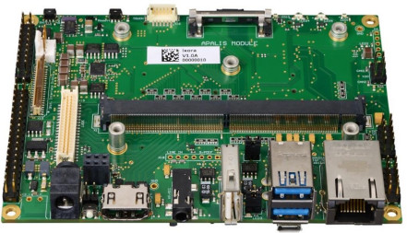

LAN Port

HDMI

USB Port

Figure 6:HDMI type A and Display port

HDMI type A Display port if used to output video. HDMI cable can be used to connect the Toradex to your monitor.

**c. Micro USB**

Micro-USB 3.0 connector; can be used to connect mouse, key board or external storage device.

9.2. Software Interface

The Industrial touch panel connects to the Toradex through LAN to provides a visual display of ventilator and alarm settings, breath waveforms, and service information.

9.3. Communication Interfaces

a. Giga Bit Ethernet

Gigabit Ethernet is part of the Ethernet family of computer networking and communication standards. The Gigabit Ethernet standard supports a theoretical maximum data rate of one gigabit per second (1,000 Mbps). Its is being used to sent data on Ventilator GUI.

1. System operations

10.1. Human Machine Integration requirements

* NuVENT is to be used, in order to safeguard use related hazards only by professionals or trained personals who have better cognizance of the system design and operation.
* In the event of any hazard due to haphazard/unanticipated dealing with its operation can endanger previous lives and in order to safe guard all alarms should be properly functioning and tested before the ventilation starts and engineering improvement could be made as the model develops.
* The maintenance of the equipment including regular check-up and cleaning properly also needs to be done by trained personal however due to lack of specialised personal, other carers could be trained whilst operating to perform maintenance and cleaning of the equipment.
* The patient circuit needs to be properly connected to the ventilator and the patient without any leakage in the circuit. In case of any leakage the alarm should trigger and any ignorance of the importance of the alarm may lead to fatal results.
* The proper connection of patient circuit by intubation during invasive ventilation should only be carried by professionals or trained personals or registered nurse at ICU in hospitals that can circumvent any untoward use hazard.
* It is important to check the patient circuit at the time of unpacking for any damage and its use should be cancelled if found otherwise.
* To avoid spread of any infectious disease the filter at the exhalation point should be regularly replaced.
* The oxygen supply values should be such that any change could be made conveniently however should be designed to be kept in locked position once changed, to avoid any fatal hazards to the patients.
* The ventilator in order to avoid any mistakenly pressed dial or button at the user interface should have a mechanism to confirm the command.
* Any change in parameter during the ventilation process will not be effective unless the knob at the interface is clicked twice otherwise after 10 second the machine ignores the command.

10.2. Maintenance Requirements

The ventilator shall provide a “*SELF-TEST* ” which shall allow the maintenance and the check-up of ventilator system service functions.

10.3. Reliability Requirements

* Immediate upgradation of the latest version of the hardware and software should be at hand so that any failure or any inoperable situation does not take place at any time and any error bugs should be dealt with a newer version of the software too.
* The user validation testing will make the equipment to be used under the intended use and environment safer and reliable assessment and evaluation should be regularly conducted for elimination of use related hazard so that criticality of the patient be kept at the forefront while operating and maintaining the system.
* Any failure in use that becomes apparent during testing phase must be resolved before time of delivery

1. System modes and Operations

**Start up transition phase**

* The touch panel is based on industrial PC which conducts its own Power On Self -Test (POST) and the whole system turns on in 90-100 seconds if any error has not occurred.
* If a critical fault is detected during POST, the ventilator shall go in an error state which will not allow ventilation.

**Power down transition phase**

* If a Power Down occurs while the ventilator is in an Active Ventilation State, the ventilator shall switch its power to internal batteries for 1.5 hours.

**Inactive ventilation state**

* The ventilator shall allow changing the current ventilation mode to any other applicable ventilation mode while ventilation support is inactive (Standby).
* The ventilator shall also allow to stop ventilation while ventilation support is inactive (Standby).

**Active ventilation state**

* The ventilator shall allow changing the current ventilation mode to any other applicable ventilation mode while ventilation support is active.
* The ventilator shall allow changing the settings in the current ventilation mode while ventilation support is active.
* During active ventilation, any setting changes in the current ventilation mode shall apply at the beginning of the next breath cycle, except for inspiratory trigger level changes which shall apply immediately.
* During active ventilation, any ventilation mode changes shall apply at the beginning of the next breath cycle.
* During active ventilation, the ventilator shall allow changing the settings in any other applicable ventilation mode prior to its activation.

**Valve or calibrated leakage configurations and detection**

* The ventilator shall include a detection of the patient circuit configuration in the self-test.

**Self-Test**

* The ventilator shall provide following self-tests which shall allow the maintenance and the check-up of ventilator system service functions.
  1. Turbine proper functioning
  2. Sensors’ proper functioning
  3. Leakage test

11.1. Ventilation modes

The different ventilation modes are explained as follows:

**1. Volume control-Assist Control (VC-AC):** The system shall provide assist/control or control breath delivery with volume controlled mandatory ventilation. AC ventilation is a volume-cycled mode of ventilation and is programmed to sense pressure changes in the body. This depends on pressure build up in the lungs of the patients during inspiration until an equilibrium is established with the ventilator. This mode is governed by delivering a fixed tidal volume (VT) with a sensitivity control which allows patients effort to cycle the ventilator. It works by setting a fixed tidal Volume at set intervals of time. The VT delivered by the ventilator in AC always will be the same regardless of compliance, peak, or plateau pressures in the lungs.

**2. Pressure Control Ventilation (PCV):** In this mode NuVent provides control breath delivery with pressure controlled mandatory ventilation. This ventilation mode is compatible with double and single limb patient circuits with an exhalation valve and single limb patient circuits.

**3. Volume Control Ventilation (VCV):** In this mode NuVent provides control breath delivery with volume controlled mandatory ventilation. This ventilation mode is compatible with double and single limb patient circuits with an exhalation valve.

**4.** **Pressure control-Assist Control (PC-AC):** Default Ventilation Mode; this relies on volume as the cycling monitor where motor driven piston delivers a predetermined volume of air. Time-cycled ventilatory support in which a nearly constant pressure is applied to the airways opening, independently of changing respiratory impedance or patient effort. The airway pressure (PEEP Positive End Expiratory Pressure plus the tidal driving pressure) is the maximum alveolar pressure to which any alveolus is exposed ensuring proper ventilation of all parts of the lung.

**5.** **Volume control -Synchronized Intermittent Mandatory Ventilation (VC-SIMV):** Intermittent Mandatory Ventilation is designed to wean patients off the ventilator which allows patients to take spontaneous breaths in between the controlled breaths as set in the machine. In SMIV which is similar to IMV the patient’s delivery of positive pressure is synchronized with the patient’s breathings and avoids over-distending the lungs when positive pressure is applied at the peak of inspiration in IMV. With this mode, which requires partial assistance from the ventilator, the ventilator will deliver a mandatory (set) number of breaths with a set volume while at the same time allowing spontaneous breaths. Spontaneous breaths are delivered when the airway pressure drops below the end-expiratory pressure (trigger). The ventilator attempts to synchronize the delivery of mandatory breaths with the spontaneous efforts of the patient. In contrast, to assist control ventilation (ACV), SIMV will deliver spontaneous volumes that are 100% driven by patient effort.

**6.** **Pressure control -Synchronized Intermittent Mandatory Ventilation (PC-SIMV):** The system ventilator shall provide synchronized intermittent mandatory ventilation breath delivery with pressure controlled mandatory ventilation and pressure support spontaneous ventilation. Here we have a controlled breath, an assisted breath and spontaneous breath where a pre-set volume is given

**7.** **Continuous Positive Airway Pressure (CPAP):** In CPAP, the ventilator maintains a constant level of pressure in the patient’s airway. CPAP machines use mild air pressure to keep the airways open, and are typically used by patients who have breathing problems during sleep. More specifically, what CPAP therapy helps accomplish is making sure that your airway doesn't collapse when you breathe while asleep.

**8. Bilevel Positive Airway Pressure (BiPAP):** It is very similar in function and design to a CPAP machine. Similar to a CPAP machine, A BiPAP machine is a non-invasive form of therapy for patients. BiPAP machines are programmed with two distinct pressures, one for inhaling and one for exhaling.

**9.** **Pressure Support Ventilation (PSV):** The ventilator shall provide spontaneous or timed breath delivery with Pressure Support spontaneous Ventilation. Pressure support (PS) may be added to enhance the volume of spontaneous breaths in Volume control-Synchronized Intermittent Mandatory Ventilation (VC-SIMV).

1. Physical characteristics
2. The base model ventilator weighs less than 10 kg.
3. The ventilator is designed such that it can be transported easily.
4. The ventilator is designed such that it can be placed at the bedside (freestanding on a nightstand). To do so, the dimensions of the ventilator shall be no more than 65 x 65 cm on the horizontal plane.
5. Environmental conditions

The ventilator shall operate within the following conditions:

* Ambient temperature range of +5°C to +40°C; 20 minutes after conditioning at 23° C. If stored outside the ambient temperature range, but within the storage range, the vent shall be fully functional 2 hours after placement in a 23° C environment.
* Relative humidity of 10% to 95%, non-condensing
* Combination 45°C and 75% humidity
* Atmospheric pressure around 100 kPa

The ventilator shall be compatible with following transport and storage conditions:

* Ambient temperature range of -10°C to +70°C
* Relative humidity of 10% to 95%, non-condensing
* Atmospheric pressure of around 100 kPa